Setting:
Nat and a human in a deserted rocky area, like a rock slide but at low altitude. No vegetation in visible distance. Nat tries to convince a human to help someone they don't know.

Human:
"I won't live, regardless of whether I do this for them or not."
1. “I won’t live” — Looking down on human, who is bent over. The stony terrain is seen in the shot, to show how isolated they are, and by implication, the plight of the unseen human.

2. “Regardless”… Close up of human

Nat:
"You need to do this."
3. Looking up at Nat (who is standing upright, with their hand up, reaching out–ish to the human): from Human's perspective

Human:
"Why should I?! I don't want any more trouble."
4. Looking at Nat closer up, from the human's perspective, as the human is there imploring.

Nat:
"Can't you feel in your heart, that even though you are nearly dead, it is what is right to do?"
5. Human looking up at the camera, signifying their pleading

Sketches:
1.
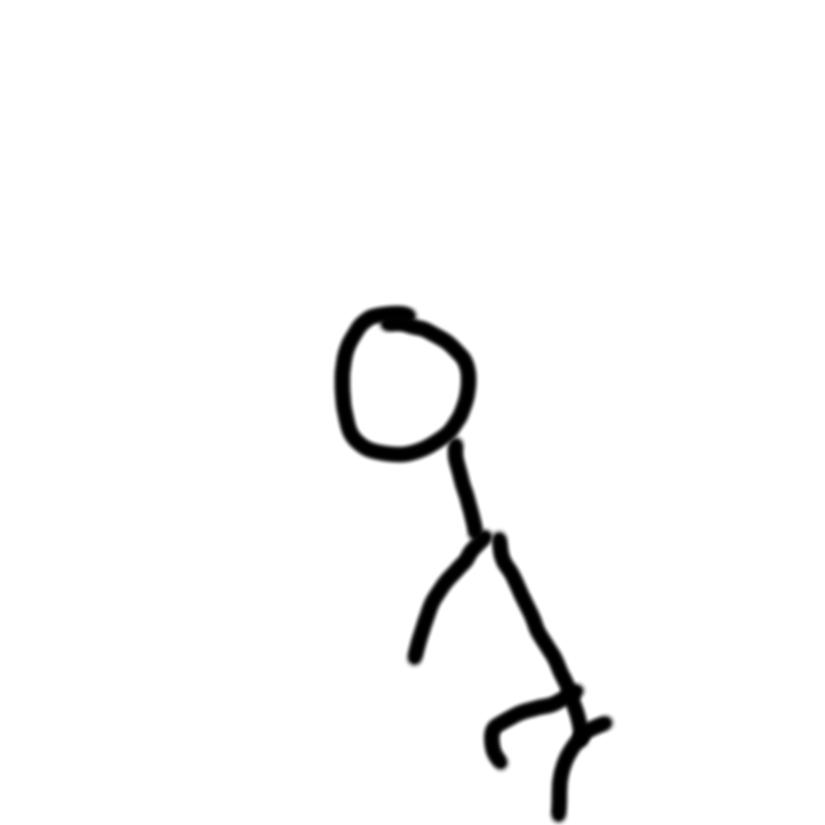
2. 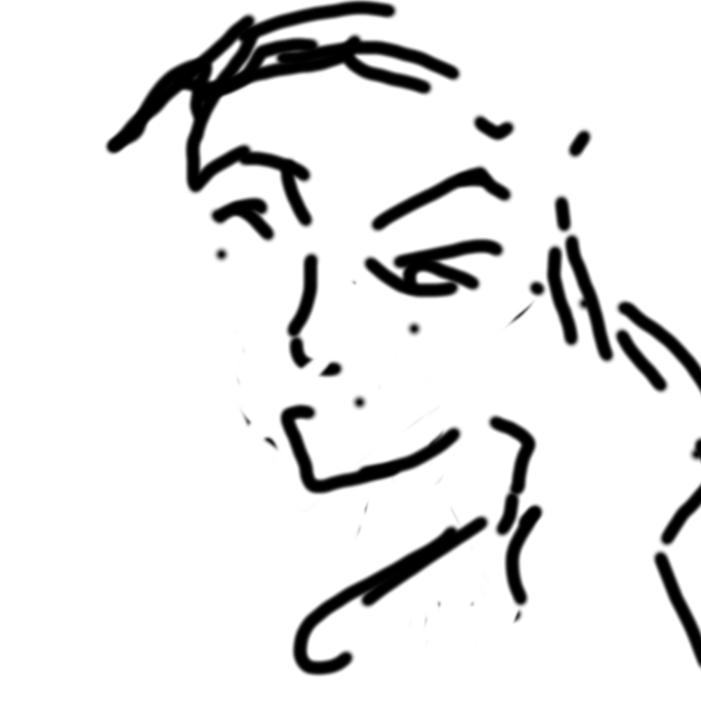
3. 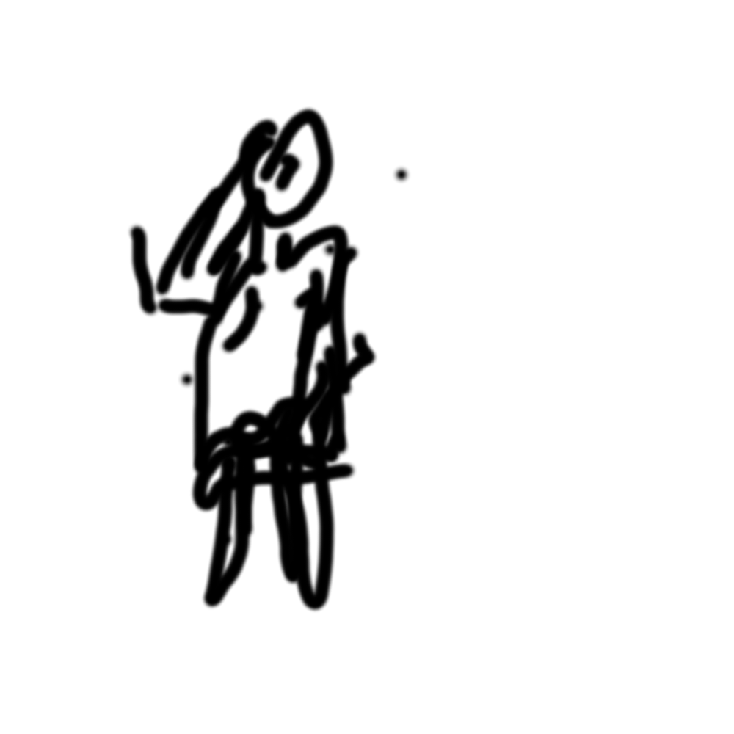
4. 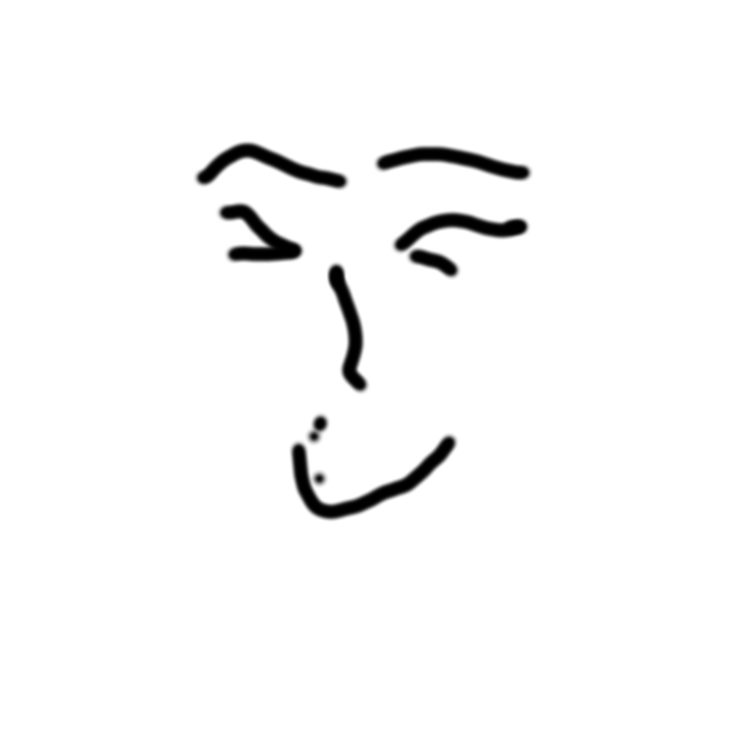
5. 